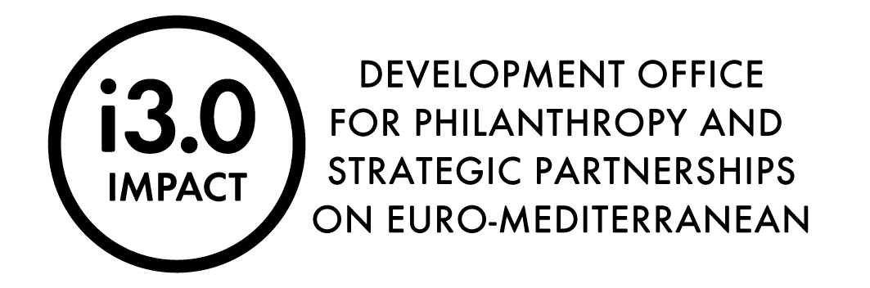

The statement should be completed by each of the organizations involved in the i3.0 Strategic Partnership only in case of the application by an international applicant.

Declaration on participation in the i3.0 Strategic Partnership

The application for the Call for expressions of interest for engagement in Strategic Partnerships for society development in Croatia and in the Euro-Mediterranean within the "Community Potentials" i3.0 program was prepared together with all organizations:

Title of the organization | Address of the organization

We have read the content of the offer that is submitted to the National Foundation for the aforementioned Call and hereby declare that we were involved in the preparation of the offer and that we agree with it.

Title of the organization | Name and surname of the responsible person | Signature of the responsible person and stamp

