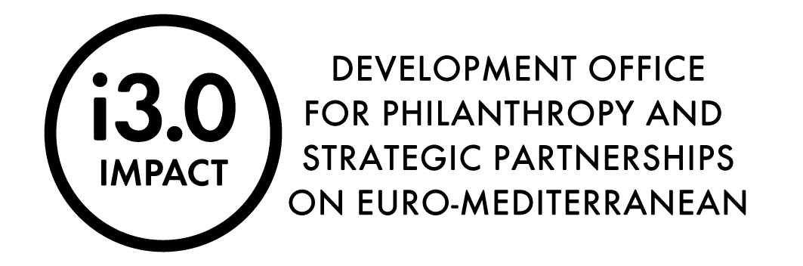

This document should be completed by the international applicant.

VERIFICATION DOCUMENT

We hereby declare that the following documentation have been uploaded to the DropBox platform by January 25, 2024 at 12:00 (noon CET):

1. Completed Application Form in open format - .doc (on the form provided by the National Foundation)
2. Completed Budget in open format - .xls (on the form provided by the National Foundation, with separate sheets for each partner included in the application)
3. Completed Declaration on participation in the i3.0 Strategic Partnership – only for international applicants in partnership with at least 1 and at most 3 organizations (non-profit or profit sector) from Croatia – (on the form provided by the National Foundation) - scanned (note: 1. a certified electronic signature in accordance with the Electronic Signature Act is also acceptable; 2. if the organization does not use a seal, when sending the document for verification via e-mail, it is necessary to attach a Declaration on non-use of the seal signed by a person authorized to represent)
4. Proof of registration for each involved organization - in the original - scanned
5. Tax Administration's Certificate on the state of debt in terms of public levies of which the official record is kept by the Tax Administration and from which it is evident that the organization has no outstanding debt – in the original. The certificate shall not be older than 30 days counting from the day of this Call's publication – scanned (only for organisations from the Republic of Croatia)

Title of the organization | Name/surname of the responsible person | Signature of the responsible person and stamp | Date

This document should be sent to the e-mail address: kodoviprijava@zaklada.civilnodrustvo.hr after uploading the documentation to DropBox, no later than January 25, 2024 by 3:00 PM (CET)

